**PRE-KCSE EXAMINATIONS JULY 2024 –BIOLOGY PP2**

**MARKING SCHEME**

**SECTION A (40 MARKS)**

1. a) Prevent excess of water/ reduce the rate of transpiration

b) Presence of chloroplasts; bean-shaped/differentially thickened walls;

c) Passage of Carbon (IV) Oxide that is a raw material for photosynthesis; Expel Oxygen which is a waste from photosynthesis;

d) drop in ATP/Energy leads to stoppage of Sodium pump thus Potassium ions migrate to epidermal cells from guard cells; Osmotic pressure of guard cells decrease; thus guard cells lose water molecules by osmosis (to adjacent epidermal cells); making the guard cells plasmolysed (thus stoma closes);

1. a) Acetylcholine; **Accept** Neurotransmitter

b) Allow passage of impulses from one nerve cell to the next; Important in learning and memory;

c) Generate more energy required for re-synthesis of acetylcholine;

d) Synaptic vesicle/B fuses with pre-synaptic membrane and bursts to release Acetylcholine into region C/Synaptic Cleft; which makes post-synaptic membrane permeable; to allow passage of Sodium ions into Y; this causes depolarization of post-synaptic membrane (and an action potential/impulse in Y);

1. a) The two genes are co-dominant; thus blend to create an intermediate/yellow phenotype;

b)

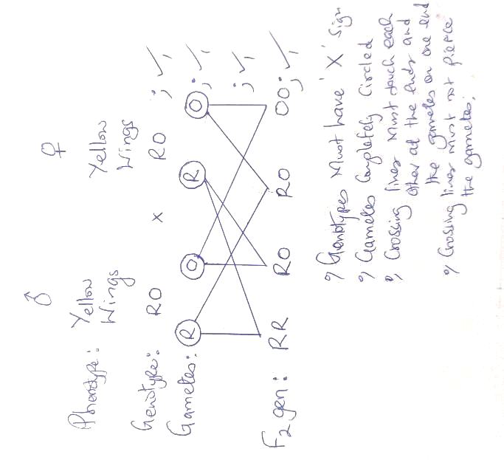

c)i) Genotypic Ratio: 1RR:2RO:1RO;

ii) 1 Red winged: 2Yellow winged: 1 Orange winged;

1. a) Has cell membrane only; Small vacuole; Centrally placed Nucleus: Mark 1st 2

b) i) Mitochondrion;

ii) Proteins;

c) i) **T**;

ii) **S**;

d) i) Help the cell detect changes in the environment; Determine how various substances enter or leave the cell cytoplasm;

ii) Determine what gets in and out of the cell:

1. a) i) 6-Bowman’s capsule;

ii) 7-Proximal Convoluted Tubule;

b) i) Create a high blood pressure to enhance ultrafiltration in region 6;

ii) Cells along walls of 3 and 4 release their Urea directly into the renal fluids;

c) secretes aldosterone hormone which increases of membranes of tubules of region 4/loop of Henle; thus more Sodium ions are re-absorbed back to the bloodstream;

d) Numerous mitochondria to generate more energy required for active transport during reabsorption of nutrients back to blood;

Numerous micro-villi to increase surface area for reabsorption of nutrients back to the bloodstream;

**SECTION B (40 MARKS)**

1. a) half mark for each correct entry

|  |  |  |  |  |
| --- | --- | --- | --- | --- |
| **Concentration of sucrose solution (mol/dm3)** | **Initial length of potato strip (mm)** | **Final length of Potato strip (mm)** | **Change in length of potato strip (mm)** | **Percentage Change in length of Potato strip (%)** |
| **0.0** | 50.0 | 53.0 | 3.0 | 6.0 |
| **0.2** | 50.0 | 52.0 | 2.0 | 4.0 |
| **0.4** | 50.0 | 51.0 | 1.0 | 2.0 |
| **0.6** | 50.0 | 50.5 | 0.5 | 1.0 |
| **0.8** | 50.0 | 49.0 | -1.0 | -2.0 |
| **1.0** | 50.0 | 48.0 | -2.0 | -4.0 |
| **1.2** | 50.0 | 48.0 | -2.0 | -4.0 |

b)i) Hypotonic/Low concentration; the potato cells gained water molecules by osmosis;

ii) Hypertonic/Higher concentration; potato cells lost water molecules by osmosis;

iii) No further osmosis; since the cells are fully plasmolysed;

c)

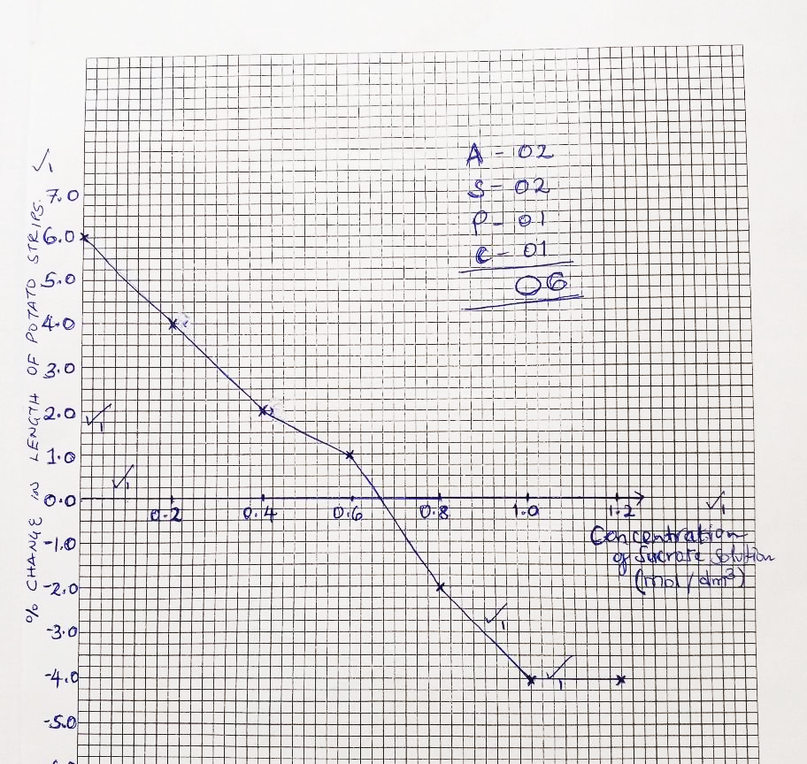

d) 0.675 mol/dm3;

e) i)Placed in distilled water/Hypotonic solution;

ii) De-plasmolysis;

f) Absorption of water in the colon/gut; reabsorption of water molecules in kidney nephrons; Osmoregulation; Mark 1st 2

1. a) do not destroy their habitat: avoid wastage by collecting just what is enough for study: do not harm the specimen: return live specimen back to their habitat after study: highly mobile animals be immobilized by use of chemicals e.g chloroform for ease of observations; handle dangerous or injurious specimen with caution; use protective gears to protect from dangerous ones; Mark 1st 5

b) i) **SKIN: leads** increased internal body temperature, Thus, There is sweating; to eliminate nitrogenous wastes/urea/excess water; this also leads to cooling of the body; after water in the sweat evaporates; blood vessels also dilate; more blood flow close to skin surface; leading to loss of excess heat by radiation/convectional current; hair on the skin also lie on skin surface to allow heat loss by radiation/convection;

ii) **HEART:** There is increased heart beat; which increase blood pressure; thus more blood pumped to muscles/blood vessels; to increase supply of Oxygen; nutrients/glucose; for continued respiration; to supply more energy needed to sustain vigorous physical activity/muscle contraction; helps faster removal of Carbon (IV) Oxide/Nitrogenous wastes to excretory organs to be removed from the body; since if left to accumulate in the body, will poison/intoxicate the body tissues;

1. a) External intercostal muscles relax; internal intercostal muscles contract; rib cage moves downwards; and inwards; diaphragm muscle relax; and diaphragm resumes its dome-shaped; volume of thoracic cavity reduce; and pressure increases; air is forced out of the lungs via trachea and nostril to th atmosphere;

b) **DRUG ABUSE: May lead to** decreased appetite and poor feeding habits thus body gets emaciated; poor absorption of vital vitamin K and E leading to infertility/poor vision; poor performance of duty/sports due to poor body posture/balance; frequent coughs and lung infection due to irritation of lungs; may lead to lung/throat cancer; may cause stomach ulcers; damage to liver and heart tissues leading to heart attack and live cirrhossis; poor body temperature regulation thus excessive heat loss; damage to brain that may lead to insomnia/lack of sleep; hallucinatios; delirium; loss of memory/amnesia; pregnancy complications and poor foetal development in women; impaired judgement that predispose one to accidents and infections like HIV and AIDS; damage to critical organs may lead to death;